# 4 Steps to Being More Productive Using Microsoft To-Do

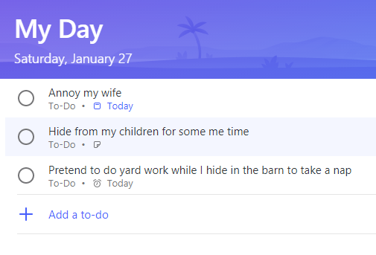

The list is the origin of culture. It’s part of the history of art and literature. What does culture want? To make infinity comprehensible. It also wants to create order — not always, but often. And how, as a human being, does one face infinity? How does one attempt to grasp the incomprehensible? Through lists — Umberto Eco

Microsoft To-Do is one of the latest apps **included in Office 365**. It’s a simple to-do list that makes it easy to plan your day. Whether it’s for work, school or home, To-Do will help you **increase your productivity** and decrease your stress levels. To-Do has a unique way to organize your tasks into lists, then combining those lists into a **My Day** view to clear the clutter and keep you organized.

## Criteria for Choosing a To-Do App

Before any decision, it’s important to lay out the criteria needed. Personally, I had 5 requirements for selecting a to-do app.

* **Security**: While you should never store passwords in your to-do app, security is still a top concern. To-Do uses encryption and stores your data in highly safe data centers managed by Microsoft.
* **Compliance: Depending on your requirements, you may not need to be compliant**. Microsoft To-Do integrates into Outlook Tasks so any compliance features that your administrator has set extends to Microsoft To-Do.
* **Access Anywhere:** Being able to access and update your to-do list on the go is more important than ever. To-Do syncs with your phone and computer, so you can access your to-dos from anywhere in the world. You can quickly add, organize, and schedule your to-dos while you’re on the go.
* **Automation**: For power users, automation becomes the key to productivity. Microsoft has just released a connector for Microsoft Flow / To-Do integration. The new integration between Flow and To-Do is going to have a tremendous affect on automating and organizing your To-Do list.
* **Ease of Use**: Any to-do app needs to be simple, fast, and easy to use. To-Do is designed with “simple mechanics”. “We designed To-Do so it’s features tend to only show up as the customer needs them.” – Simon Chan

## Introduction to Microsoft To-Do

To-Do is a simply yet powerful app to help you organize. When using Office 365, To-Do comes packaged with your service. The tasks are all synced back to your Outlook tasks for a simple, secure, and integrated experience. What’s truly unique about To-Do is the simply My Day view. You can sort and group all your tasks logically, then on a daily basis add the tasks to your My Day view. This simple design helps you stay focused while being able to stay organized.

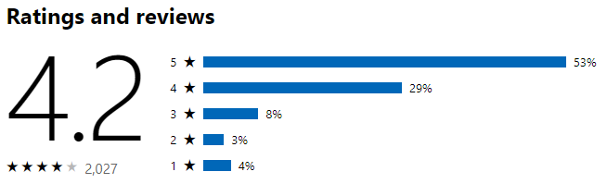

### Microsoft To-Do has a Simple Break Down for Organization

1. **Lists**: A way to organize tasks by different groups, for example work or personal.
2. **Tasks**: A item on your to-do list. Each task can have notes, reminders and be set reoccurring.
3. **Steps**: Also known as a sub-task, steps help break down tasks into smaller more manageable chunks.
4. **My Day**: A special view that you can add tasks to organize your daily to-do list across your lists clearing the clutter of less important tasks.

## 1. Create Lists and Tasks for Everything

Your mind is for having ideas, not holding them — David Allen

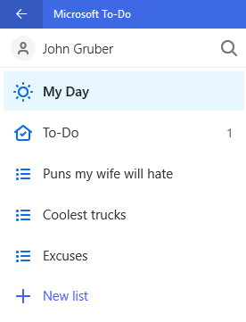

David Allen is the master of to-do lists and has dedicated his life to helping people apply order to chaos and get more done. David’s first recommendation would be to jot everything down. Get all the tasks out of your head. Once the tasks are out of your head you can breathe easier knowing exactly what needs to be done and not forget a thing.

Every to-do app has two goals: improve productivity and relieve stress and Microsoft To-Do’s flexible design can help you do just that. Quickly create lists to organize tasks then create tasks in each list. Stay organized, without unnecessary complexity. As a task may grow to need multiple steps, you can add steps to the tasks. Simple, organized, and fast.

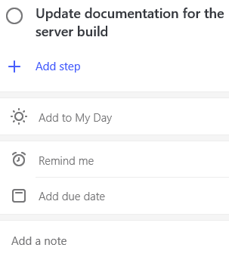

## 2. Prioritize Daily

Start by doing what’s necessary; then do what’s possible, and suddenly you are doing the impossible. — Francis of Assisi

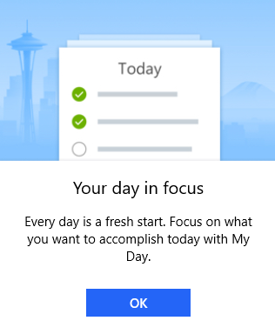

Microsoft To-Do has a unique design based on My Day. The **My Day** view is used to clear the clutter from your list of today’s actionable items. Start every day by reviewing your lists and moving priority tasks to the My Day view. The **My Day list is the heart of Microsoft To-Do and what makes it truly unique**. It’s designed around clearing the clutter and prioritizing what’s important for the day. At the end of each day review your list and check off your completed tasks.

## 3. Ask for Help

Get the master of arithmetic to show you how to square a triangle. — Leonardo da Vinci

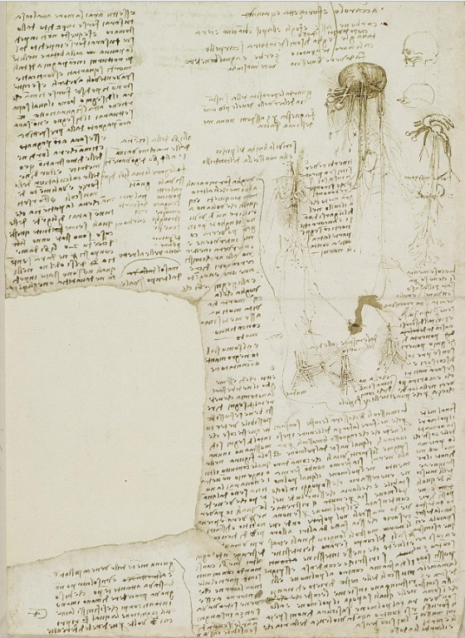

In Leonardo da Vinci’s 500-year-old to-do list there were a ton of to-do items where he planned to ask others how things work. Leonardo’s relentless pursuit of knowledge is a lesson for us all. Add tasks to follow-up with people, remind yourself to spark a conversation, and don’t be afraid to ask someone else to help when you’re feeling overwhelmed. The best organizations work because people work as a team.

## 5. Create a Bucket List

My mission in life is not merely to survive, but to thrive; and to do so with some passion, some compassion, some humor, and some style. — Maya Angelou

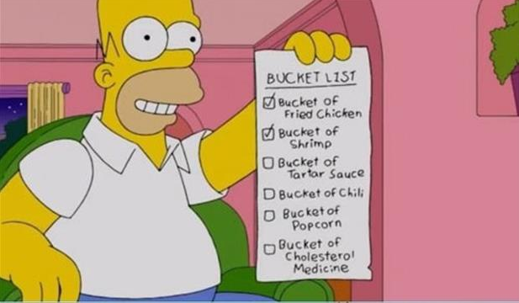

We all have life goals. From getting more organized to finding more time to annoy our wives. Put all these long-term goals in a list and review them daily, weekly, or monthly. When possible, create a to-do item to get yourself closer to your dreams. **Setup reoccurring tasks to remind yourself to spend 15 minutes a day learning a new language.** Make your dreams a reality, make them a priority, and let your to-do app help you stay on top of it.

## The Future of To-Do

Microsoft To-Do is a rapidly growing and evolving app. Microsoft has promised to decommission Wunderlist once To-Do has all its best features. Below is a quick list of features we can expect from To-Do in the future:

1. Folders — To organize lists.
2. Sharing — To share a to-do list or task with others.
3. Tags — To help organize across lists.
4. Comments — To keep more complex tasks moving forward and organized.
5. Integrations — To integrate with everything!

To-Do has the Wunderlist team dedicated to its development and they’re adding features quickly. Keep up with changes and make your voice heard by using <https://todo.uservoice.com/>.